Oyster Mushroom Grow Kit Instructions

Once the sawdust substrate inside the bag is fully white, this means the mushroom body is ready to produce mushrooms. The white you see in the bag is the living body of the mushroom producing fungi known as mycelium. It will take an environmental change in order to signal the mycelium to reproduce, creating mushrooms. With oyster mushrooms, this doesn’t take much to happen.

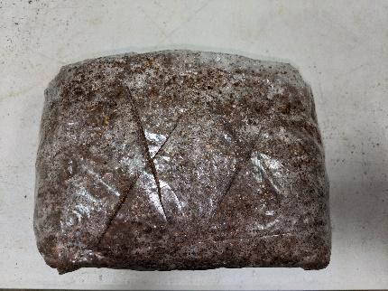
- On the opposite side of the white filter patch on the bag, cut two 2” X’s with a sharp knife. Try to cut the bag and not the mycelium; however, it will recover if you do.

- Fold the top of the bag around the substrate creating a tight brick looking block with your cut X’s face up towards the ceiling.

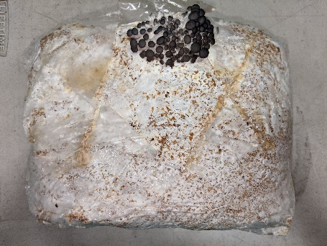
- Here is the most important part: keep the exposed surface of the mycelium moist until the fruiting mushrooms begin the emerge. Using a spray bottle, mist the cuts several times a day. To keep moist in between misting, place a plastic bag lightly over the slits; unless in an environment where the RH is kept at 80% or higher. This micro climate will allow for fresh air to signal the mushrooms to begin to form.
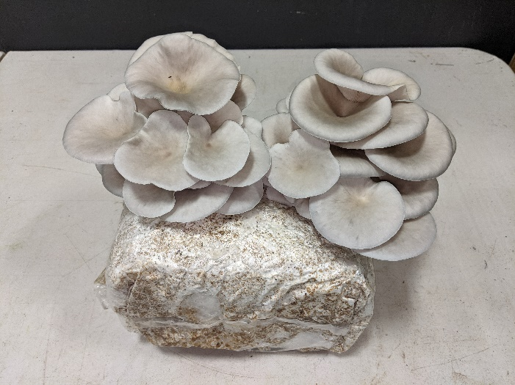
- Once the mushrooms begin to ‘pin’, simply spray as often as possible, up to 6 times per day. In a few days, depending on the temperature in the room, you will have fully edible mushrooms.

